# Data Sets Visualization – Tasks 6-7

## Task 6

1. Draw the best visualization of “history” (or “art” graph).

The visualization of “history” graph is shown below.

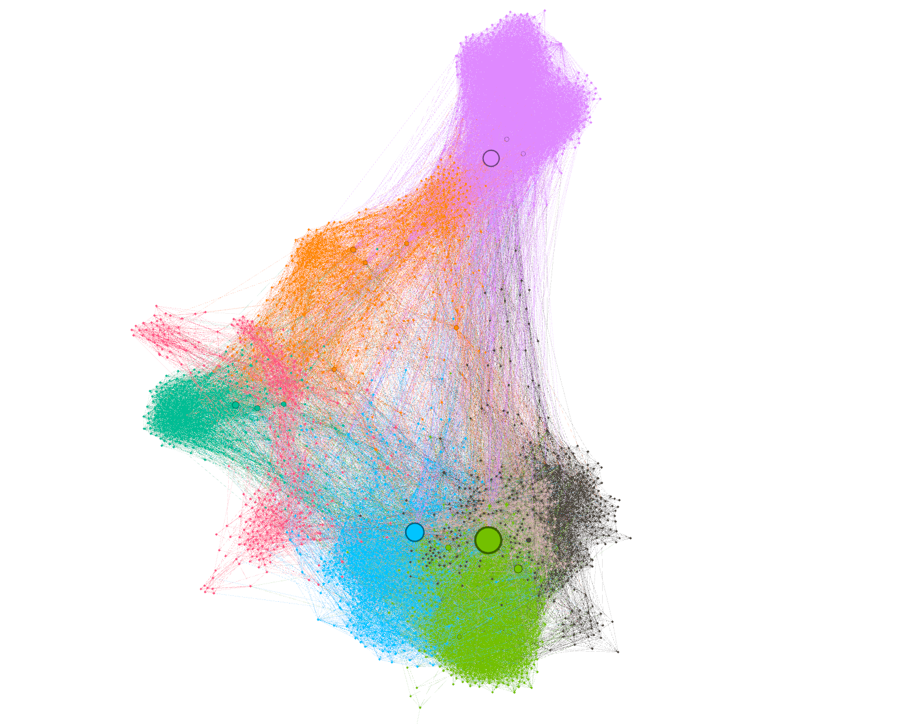

1. Discuss the conclusions on the basis of coarse grained and fine-grained graph features.

The graph above was made using modularity (community detection algorithm), Force Atlas 2 layout with prevent overlap option turned on. The size of nodes represents betweenness centrality (how often a node appears on shortest paths), colors represent modules based on the Gephi Modularity algorithm.

The most central nodes are: World War II (green), World War I (blue), American Civil War (purple), Napoleonic Wars (dark green), American Revolutionary War (orange). More contemporary military conflicts (Cold War, Vietnam War) are in black. The Cold War is quite close to the World War II. The red nodes represent other wars or people/event related to them, from the ancient and later history (Trojan War, Margaret of Anjou, etc.).

There is one orange element in the middle of the graph (see below, Outline of American History) connected to many other nodes, but its betweenness centrality is not very high. It is linked to other nodes with greater centrality (listed above).

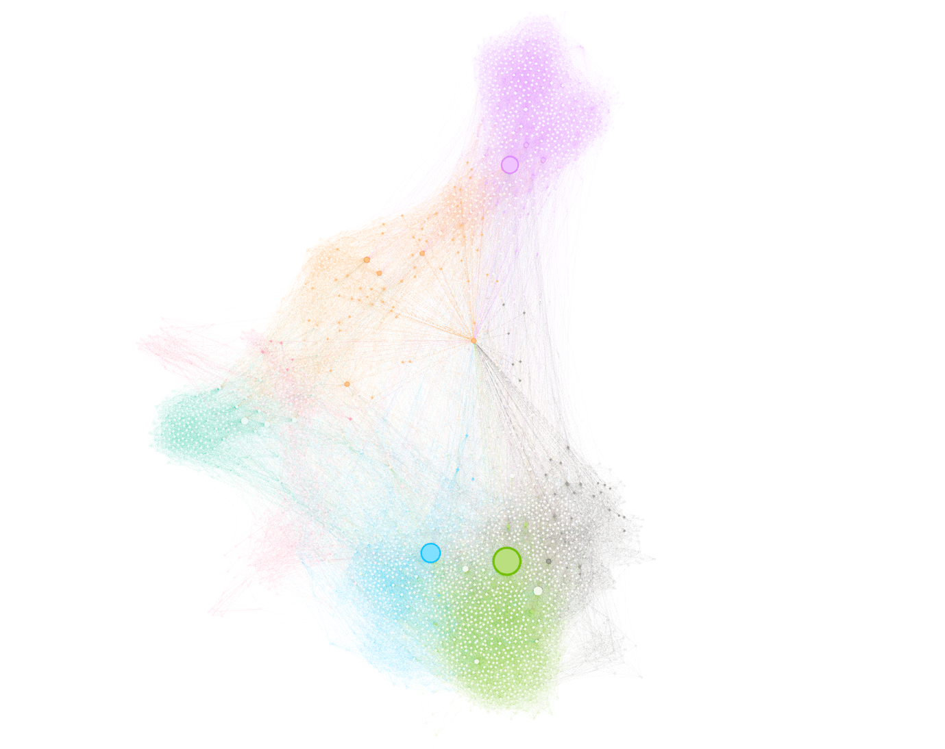

1. What the most surprising information can you conclude from visualization

The most surprising thing is that our history in Wikipedia is dominated by wars, great generals, kings and queens, less related to great discoveries and any other (scientific or cultural) achievements of the mankind.

One of the non-war examples (but still connected to many military events) is black people node, placed centrally in the graph and linked to all its parts (see the figure below).

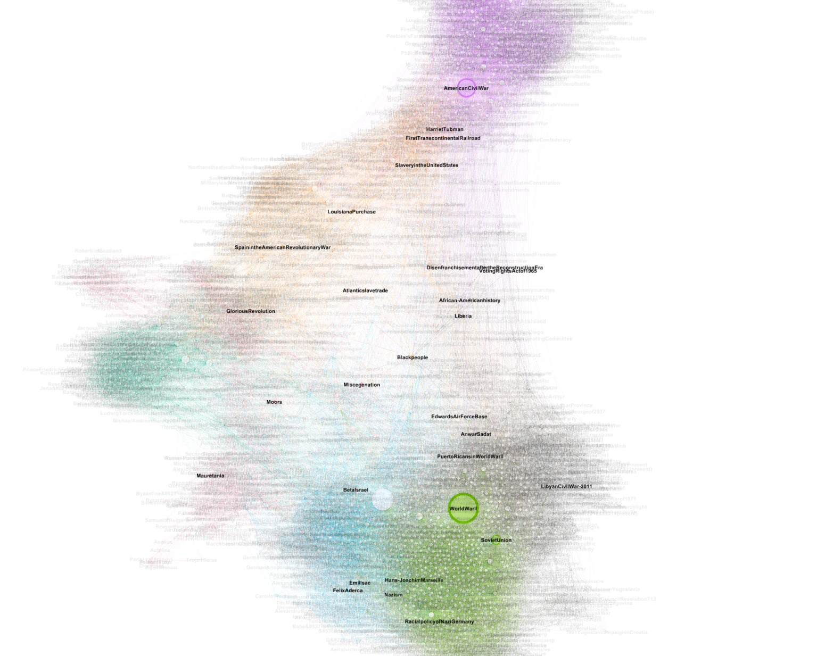

## Task 7

1. Draw the visualization of the KNN graph representing the baseline datasets FMNIST, CIFAR 10, TNG.

Below, there is FMNIST ([Fashion MNIST Zalando dataset](https://github.com/zalandoresearch/fashion-mnist)) in represented by a graph.

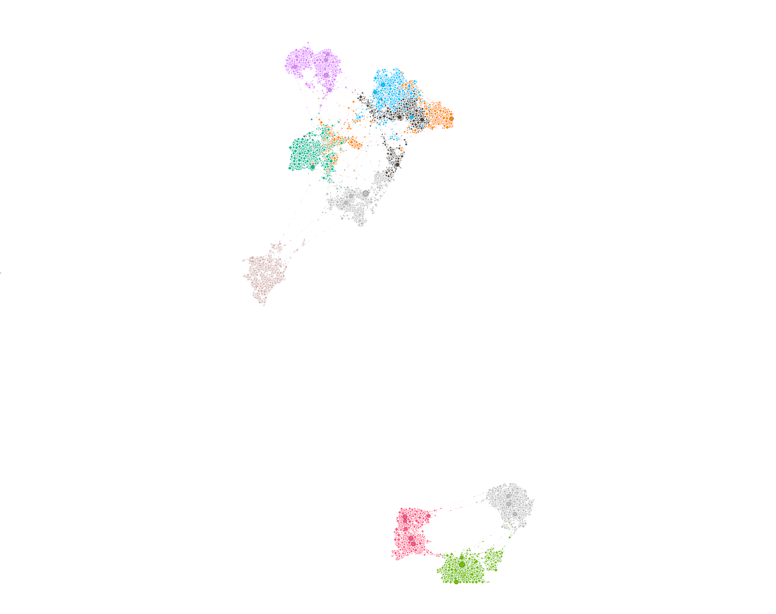

The classes defined in the dataset are as follows:

* 0: T-shirts
* 1: trousers
* 2: sweatshirts
* 3: dresses
* 4: jackets
* 5: feminine shoes
* 6: shirts
* 7: sports shoes
* 8: bags
* 9: winter shoes

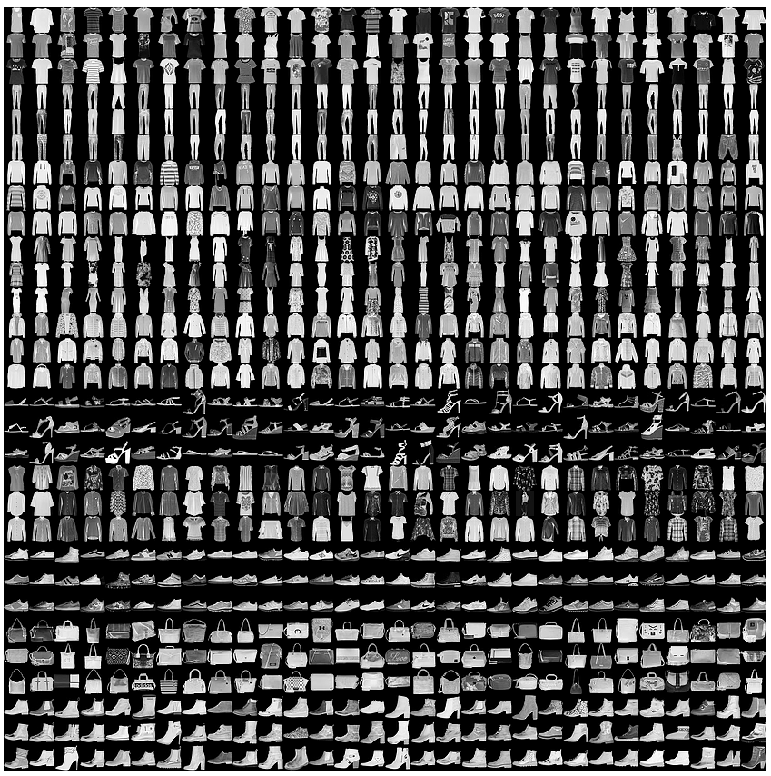

1. Compare classes with modularities.

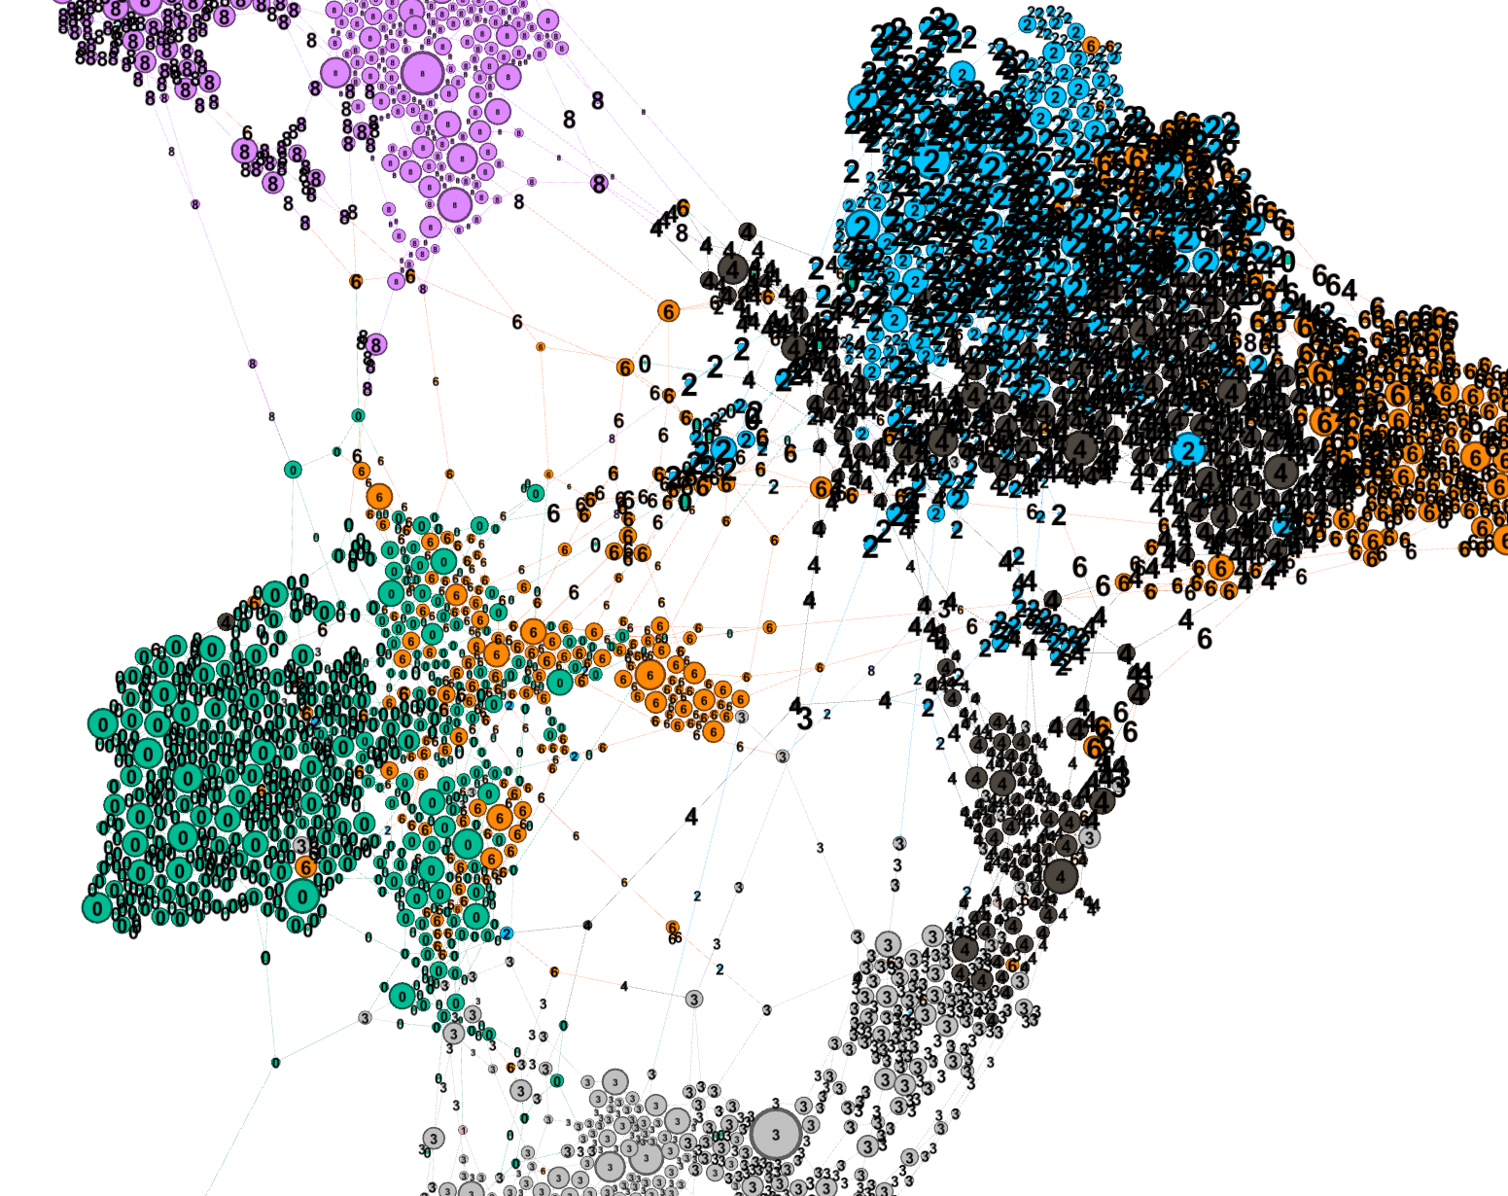

The classes match modularities very well.

1. What can you observe?

Most of clothes classes are nicely separable. In the bottom part of the graph (not connected to the main part – see below), there are shoes classes (feminine, sports and winter).

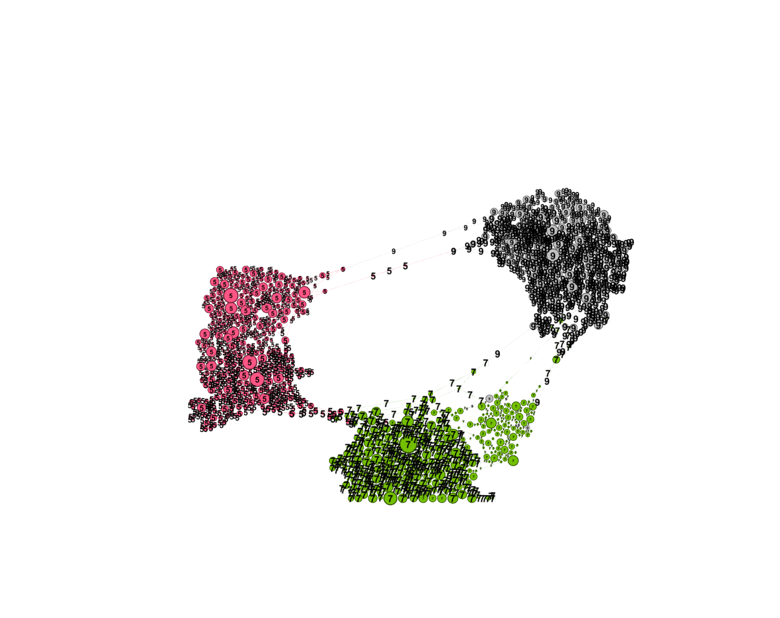

In the main part of the graph (see below), bags (purple) are well separated from the tops (shirts and jackets), t-shirts and dresses. The most problematic classes for the modularizer algorithm are sweatshirts, jackets and shirts (blue, orange and black). This is not surprising as they have similar shapes. Trousers stan out from other classes as well.

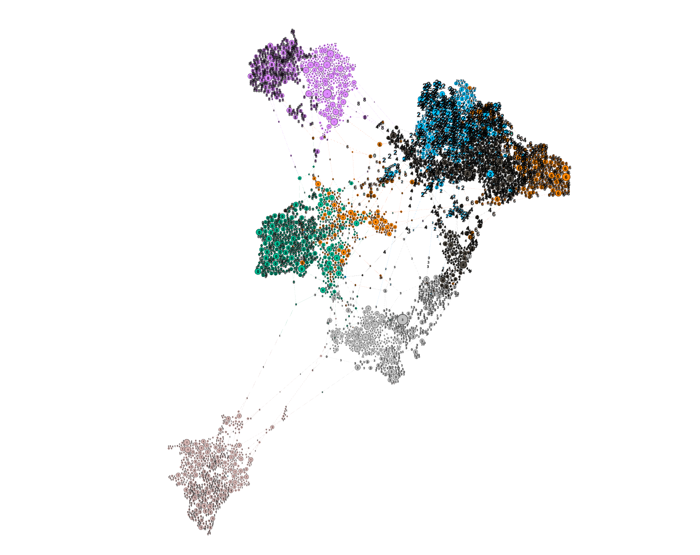

There is a small group of winter and sport shoes being far away from the cluster (see the small island in the left bottom part of the image below).

